**Ransomware Detection System**

**Explanation of Implementation: -**

The Central Web Monitoring UI:-

Login Page:-

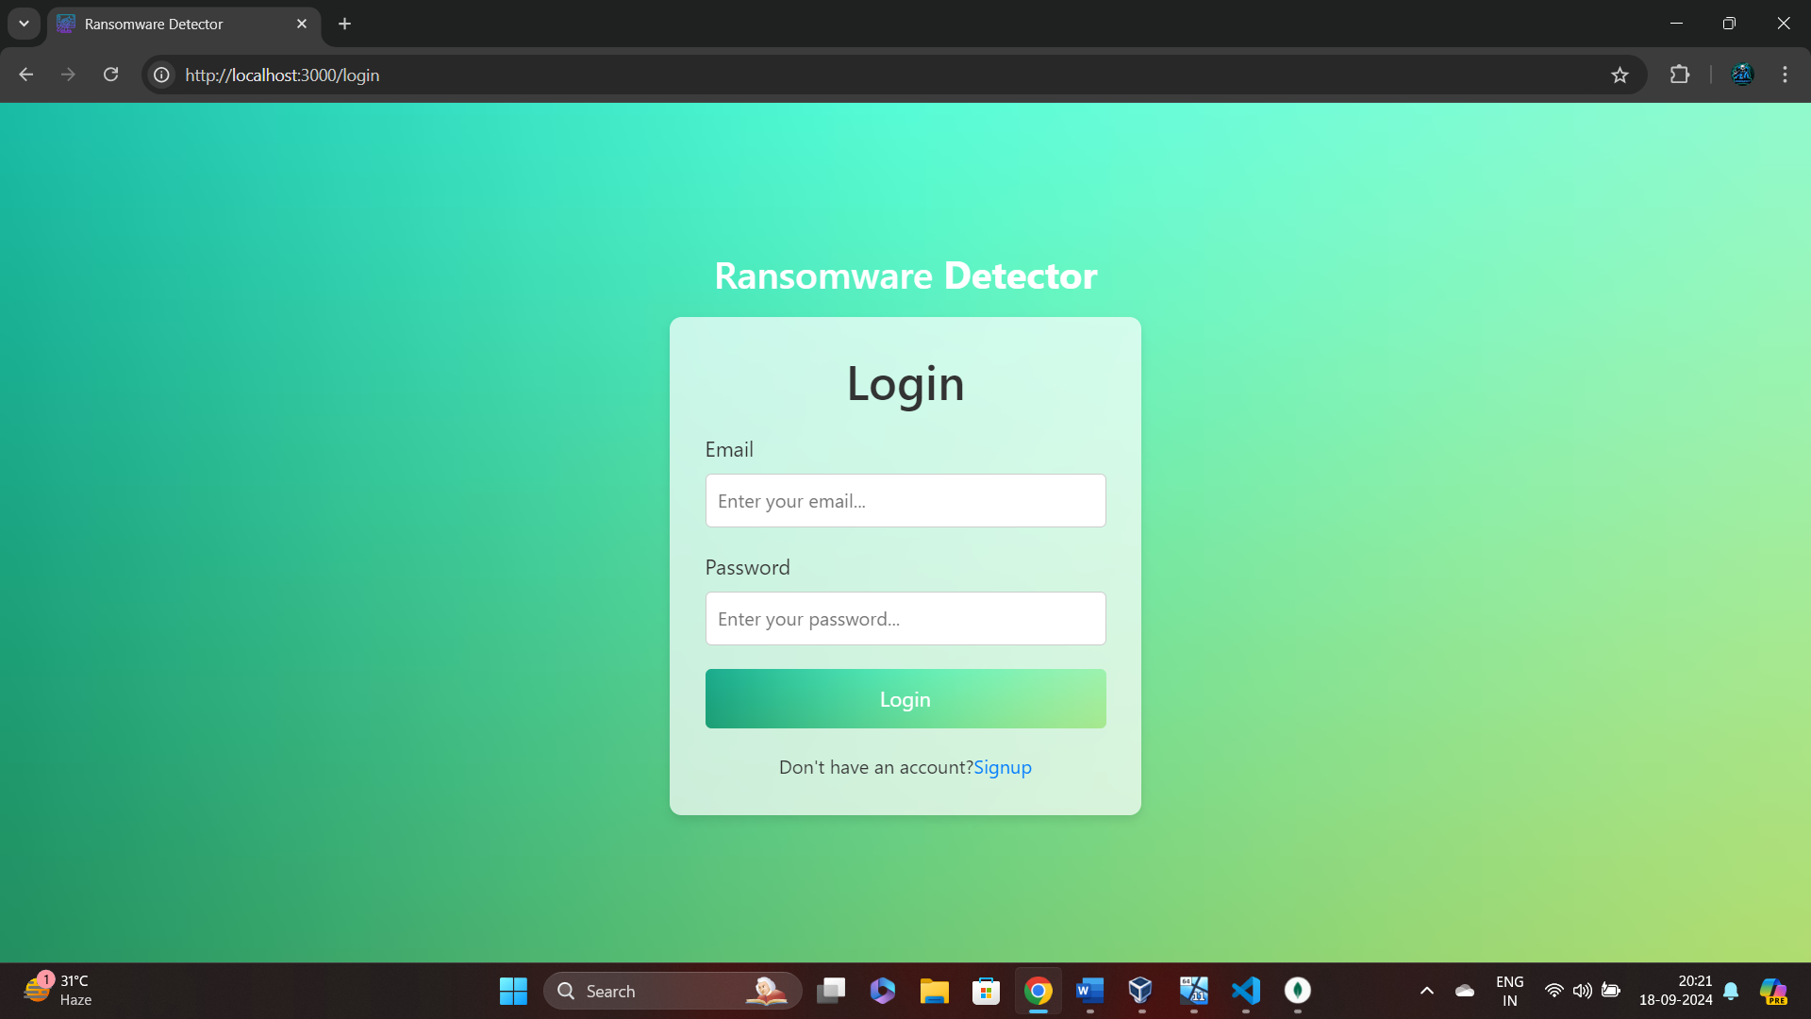

Registration Page:-

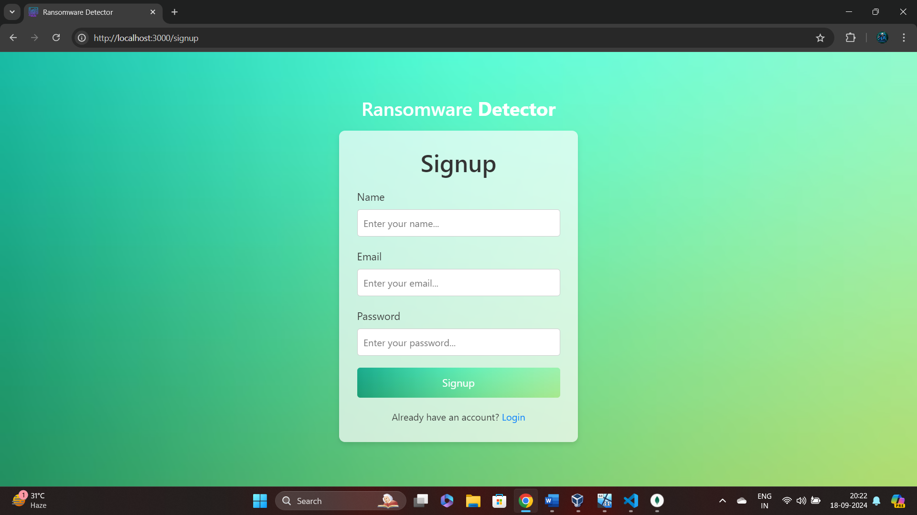

As soon as someone registers it gets stored in the Database for future login:-

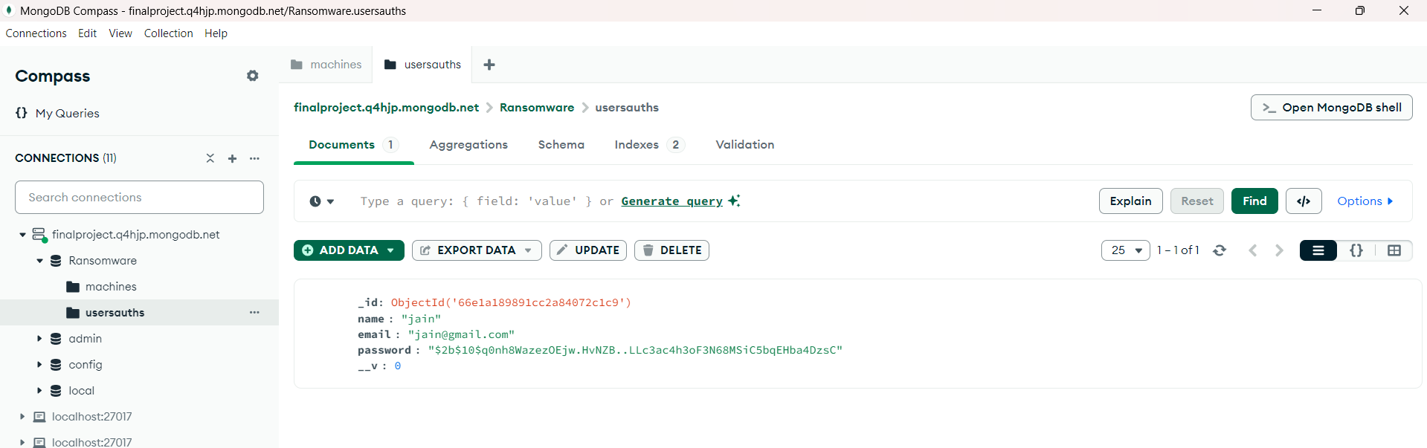

The main Page where user can view their stored information of machines:-

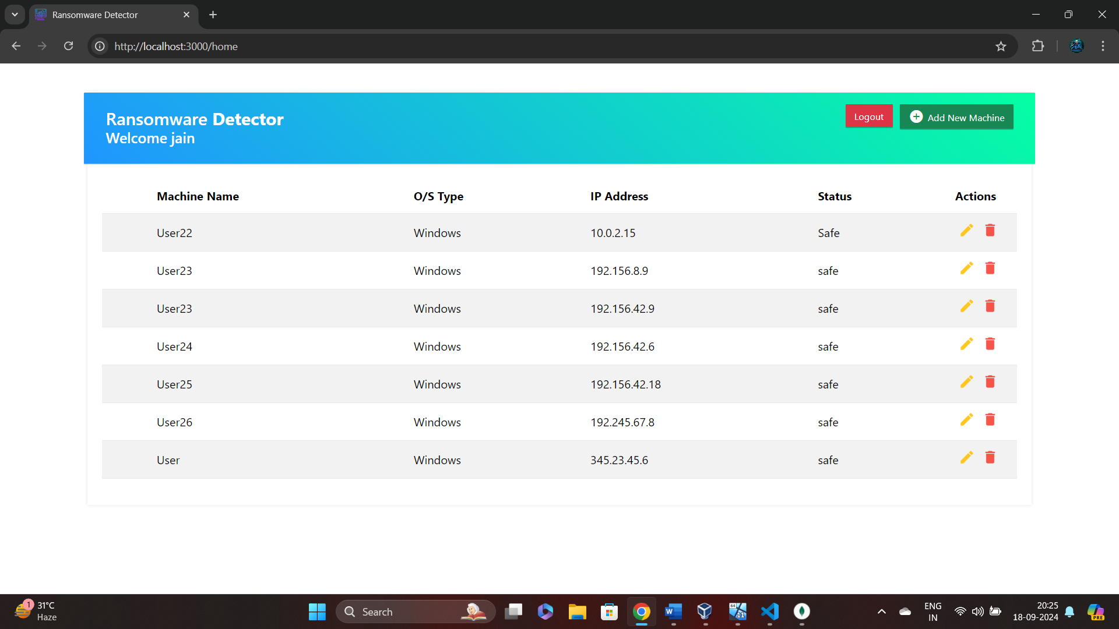

The Add Machine Form to help the user to add new machine:-

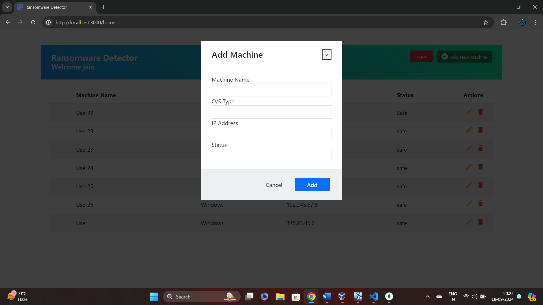

The Update Machine Form to help the user update their previously stored machine:-

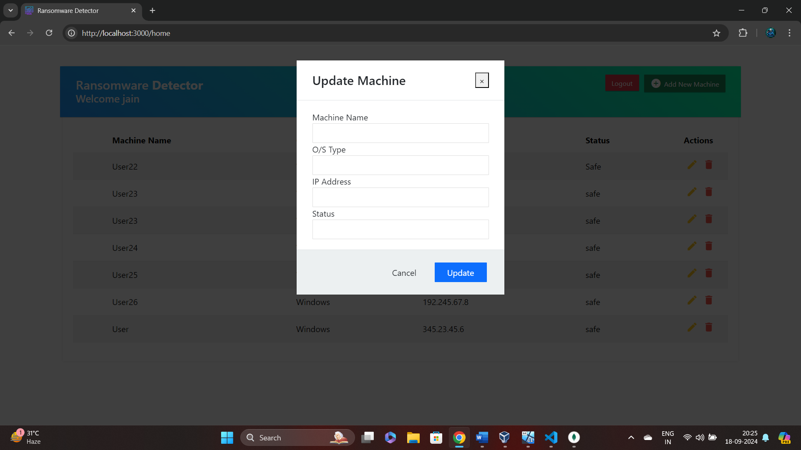

The Delete Machine icon to help the user to delete the machine:-

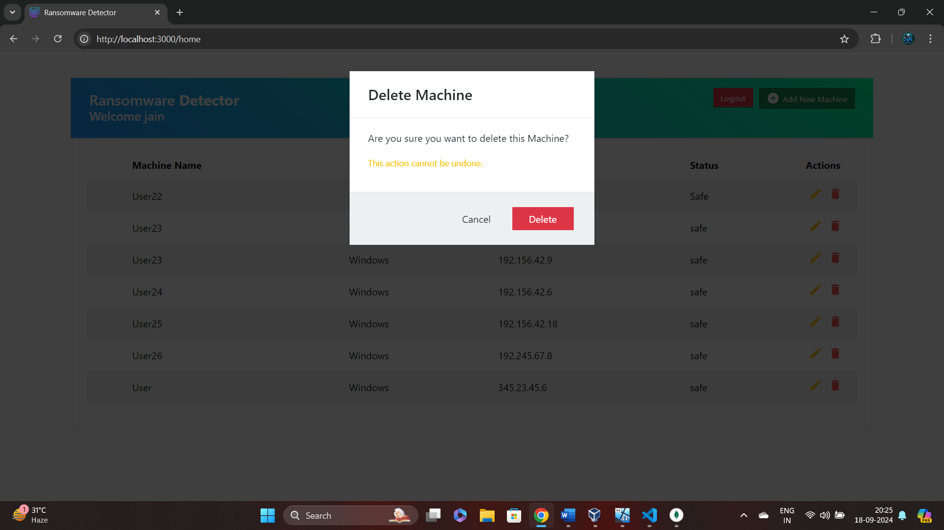

As soon as you add the machine info it also gets add to the database:-

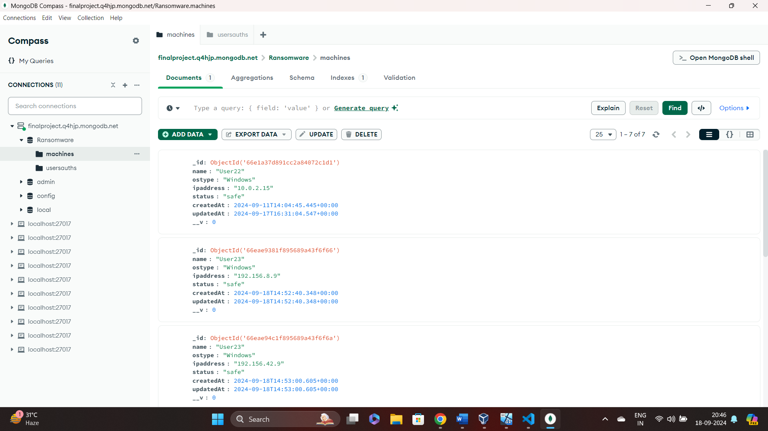

Now let see the working of Ransomware Detector:-

This is the virtual windows machine with the IP Address “10.0.2.15” which is victim machine on which the Ransomware attack is performed and it detects:-



Here The folder “impfiles” is normal as well as all files and sub folder are normal:-

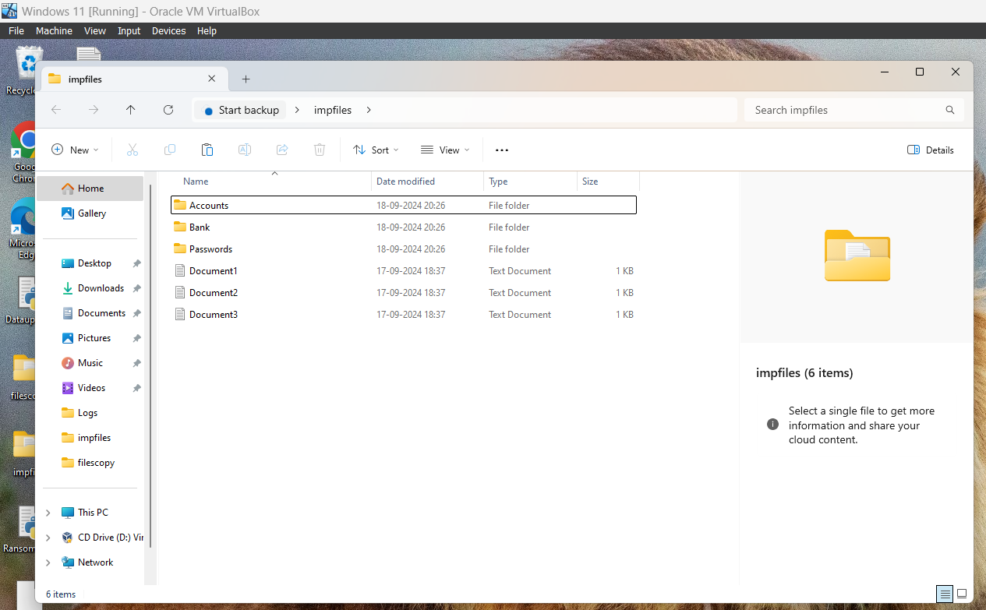

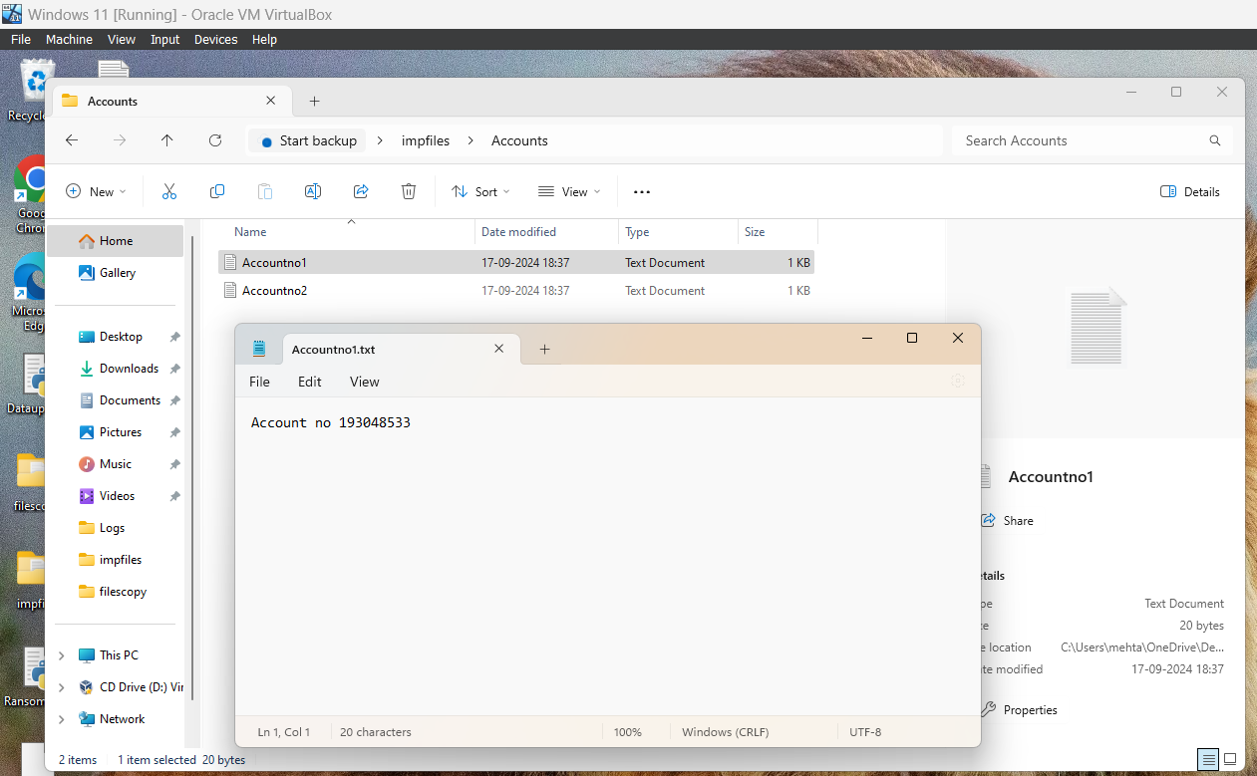

Now we will run the “IntelligentAgent.py” script it continuously calculates ,scan and compare the hash values of the files and the sub-folder present in the folder:

As soon as you run it first time it calculates and store the hash values of all files in the .json file for further comparison and detection:-

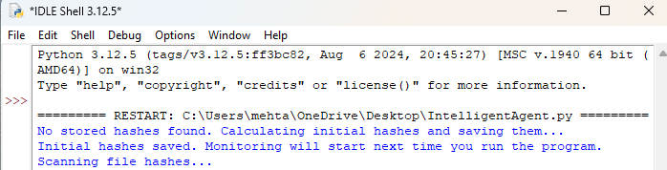

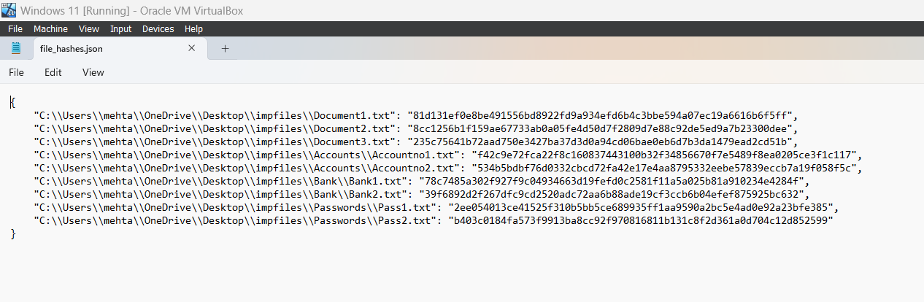

This script continuously scan the hashes compares it if there are any changes it records the current hashes continuously: -

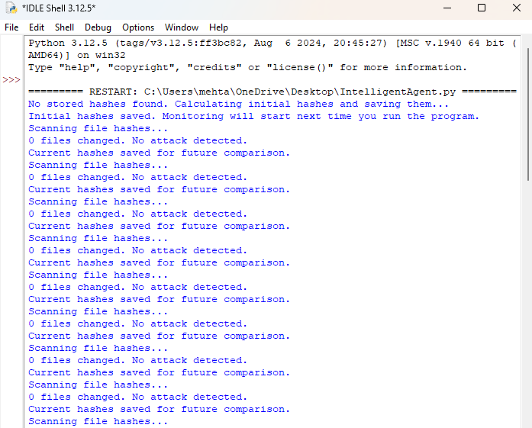

Now we will run the “RansomwareCreator.py” which encrypts all the files and sub-folder which are present in “impfiles” folder to simulate Ransomware attack:-

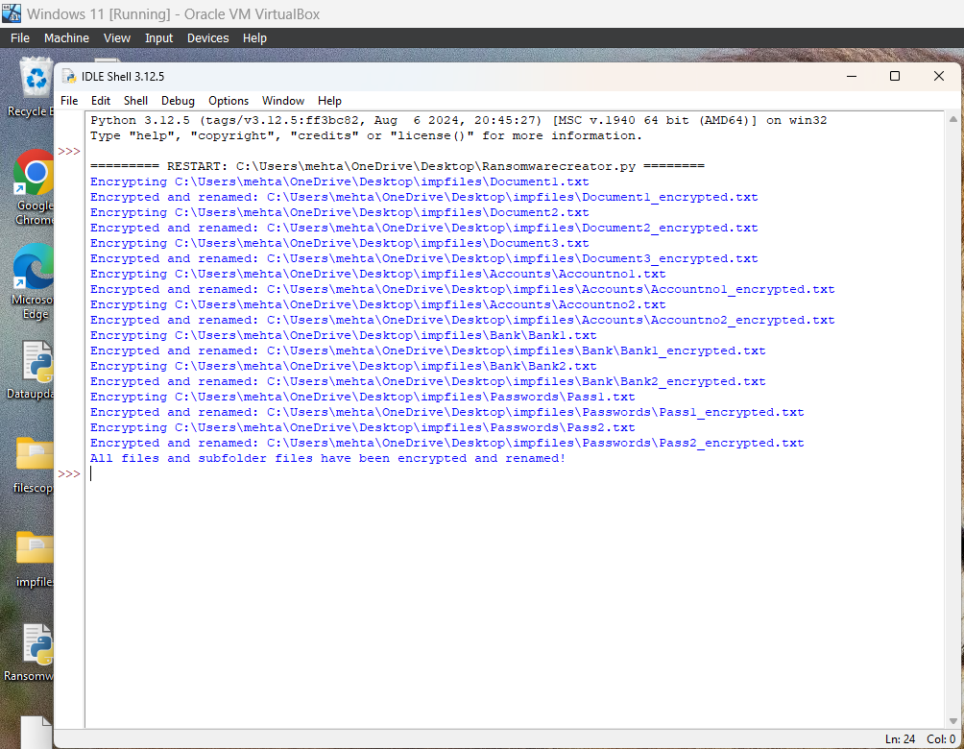

Now you can see all files are encrypted in “impfiles” folder :-

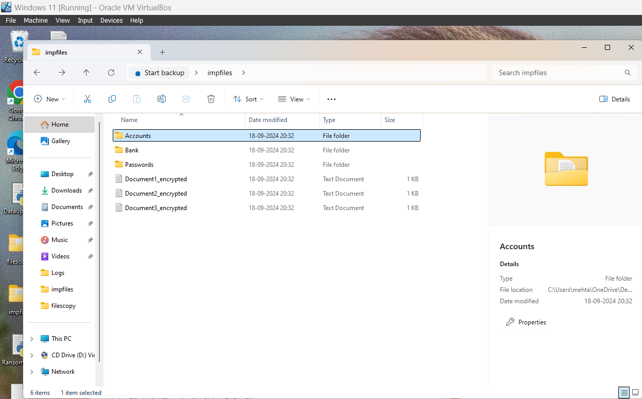

As soon as you open any file it is encrypted:-

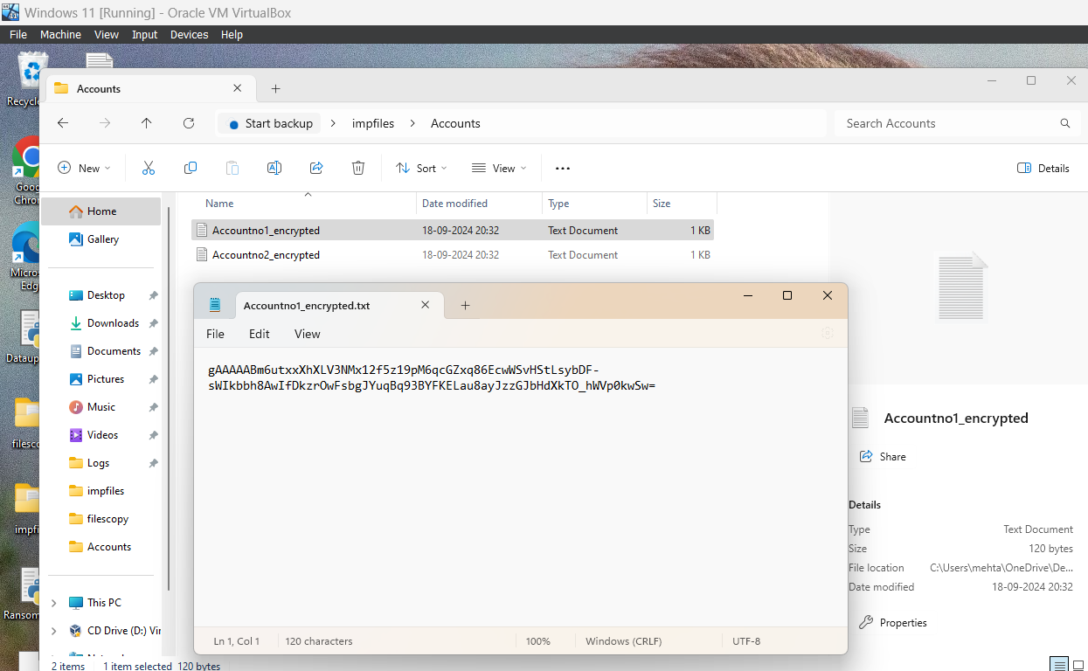

As all files got encrypted the hash value will also get changed and store:-

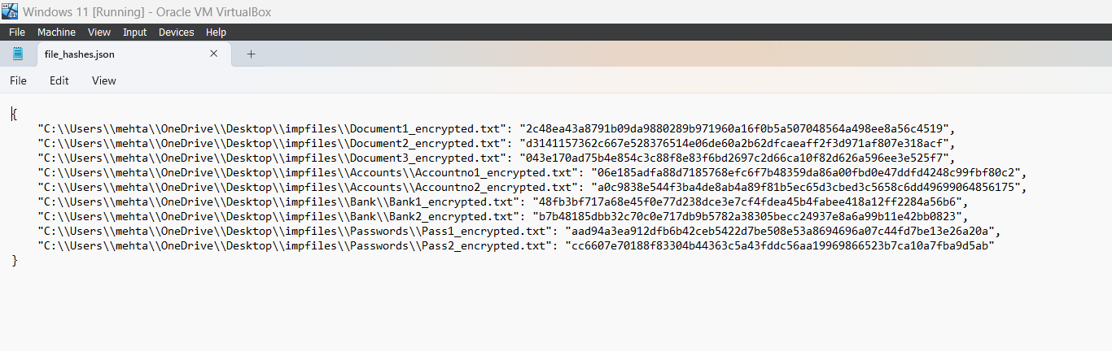

As soon as the hash value of more than five file changes it scans and detects the attack:-

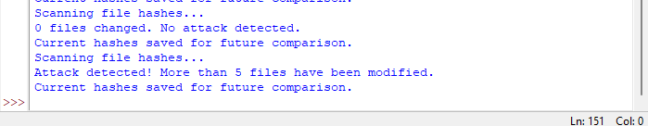

As soon as the attack is detected the alert occurs on the virtual windows system:

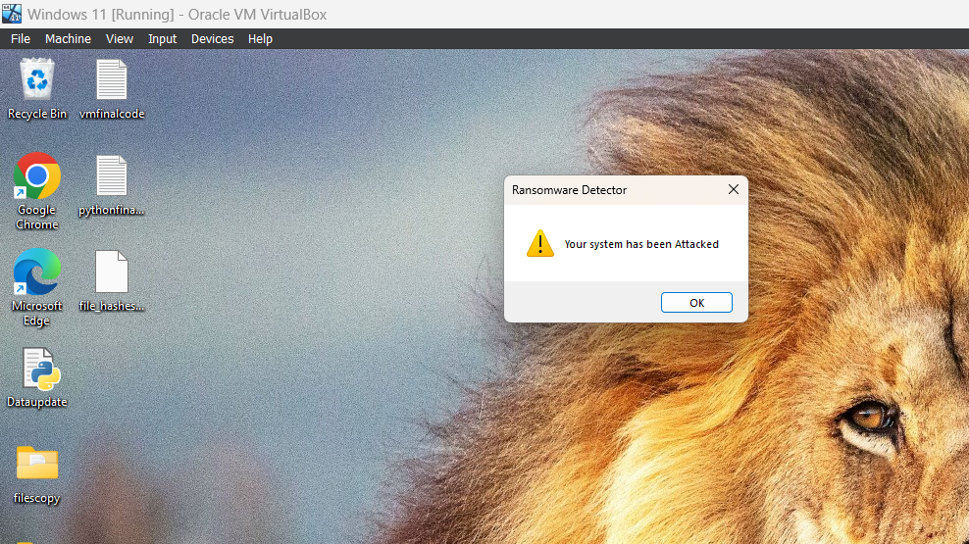

As well as the admin machine where the centralised web monitoring UI also gets the alert and the status of the same machine with IP address (10.0.2.15) is changed to attack:-

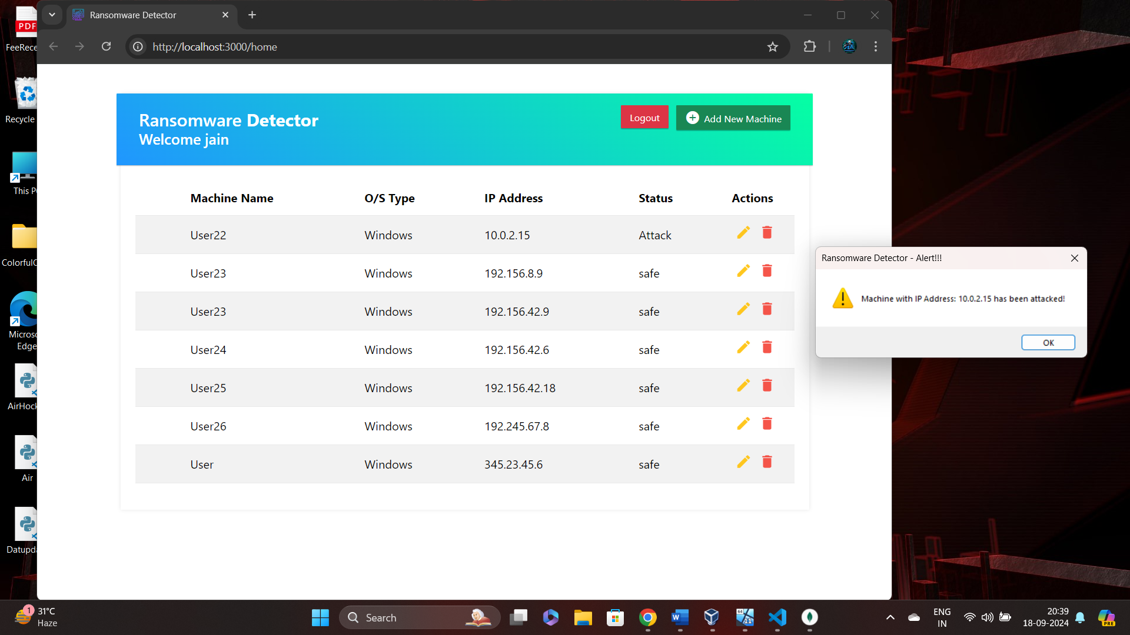

As well as it also change the status with IP on which attack is detected in the database too:-

